**Type Reflection, Late Binding, and Attribute-Based Programming**

As shown in Chapter 14, assemblies are the basic unit of deployment in the .NET universe. Using the integrated object browsers of Visual Studio (and numerous other IDEs), you are able to examine the types within a project’s referenced set of assemblies. Furthermore, external tools such as ildasm.exe allow you to peek into the underlying CIL code, type metadata, and assembly manifest for a given .NET binary. In addition to this design-time investigation of .NET assemblies, you are also able to programmatically obtain this same information using the System.Reflection namespace. To this end, the first task of this chapter is to define the role of reflection and the necessity of .NET metadata. The remainder of the chapter examines a number of closely related topics, all of which hinge upon reflection services. For example, you’ll learn how a .NET client may employ dynamic loading and late binding to activate types it has no compile-time knowledge of. You’ll also learn how to insert custom metadata into your .NET assemblies through the use of system-supplied and custom attributes. To put all of these (seemingly esoteric) topics into perspective, the chapter closes by demonstrating how to build several “snap-in objects” that you can plug into an extendable desktop GUI application.

**The Necessity of Type Metadata** The ability to fully describe types (classes, interfaces, structures, enumerations, and delegates) using metadata is a key element of the .NET platform. Numerous .NET technologies, such as Windows Communication Foundation (WCF), and object serialization require the ability to discover the format of types at runtime. Furthermore, cross-language interoperability, numerous compiler services, and an IDE’s IntelliSense capabilities all rely on a concrete description of type.

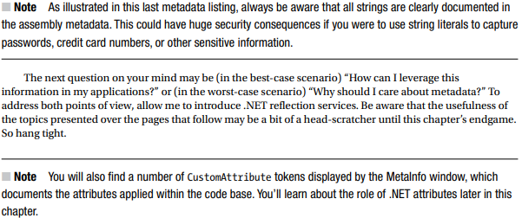**Viewing (Partial) Metadata for the EngineState Enumeration** Each type defined within the current assembly is documented using a TypeDef #n token (where TypeDef is short for type definition). If the type being described uses a type defined within a separate .NET assembly, the referenced type is documented using a TypeRef #n token (where TypeRef is short for type reference). A TypeRef token is a pointer (if you will) to the referenced type’s full metadata definition in an external assembly. In a nutshell, .NET metadata is a set of tables that clearly mark all type definitions (TypeDefs) and referenced types (TypeRefs), all of which can be viewed using ildasm.exe’s metadata window. As far as CarLibrary.dll goes, one TypeDef is the metadata description of the CarLibrary. EngineState enumeration (your number may differ; TypeDef numbering is based on the order in which the C# compiler processes the file).

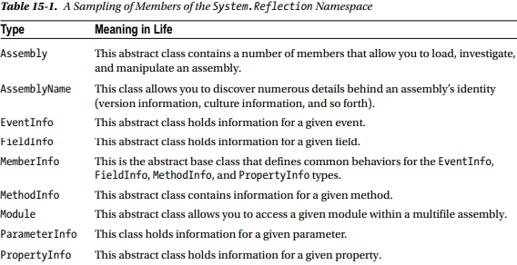**Understanding Reflection** In the .NET universe, reflection is the process of runtime type discovery. Using reflection services, you are able to programmatically obtain the same metadata information displayed by ildasm.exe using a friendly object model. For example, through reflection, you can obtain a list of all types contained within a given *.dll or *.exe assembly, including the methods, fields, properties, and events defined by a given type. You can also dynamically discover the set of interfaces supported by a given type, the parameters

**The System.Type Class**

The System.Type class defines a number of members that can be used to examine a type’s metadata, a great number of which return types from the System.Reflection namespace. For example, Type.GetMethods() returns an array of MethodInfo objects, Type.GetFields() returns an array of FieldInfo objects, and so on. The complete set of members exposed by System.Type is quite expansive; however, Table 15-2 offers a partial snapshot of the members supported by System.Type (see the .NET Framework 4.6 SDK documentation for full details).

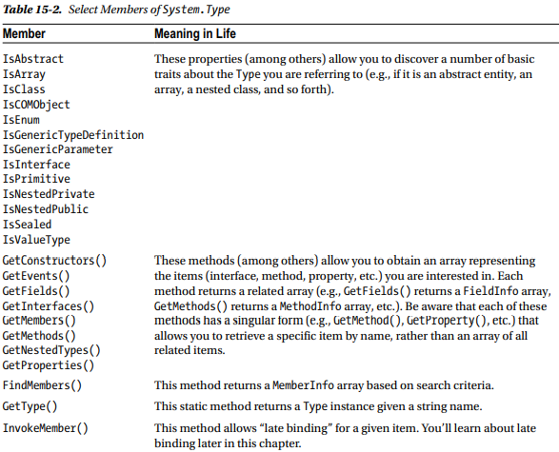**Obtaining a Type Reference Using System.Object.GetType()** You can obtain an instance of the Type class in a variety of ways. However, the one thing you cannot do is directly create a Type object using the new keyword, as Type is an abstract class. Regarding your first choice, recall that System.Object defines a method named GetType(), which returns an instance of the Type class that represents the metadata for the current object.

**Building a Custom Metadata Viewer** To illustrate the basic process of reflection (and the usefulness of System.Type), let’s create a Console Application project named MyTypeViewer.

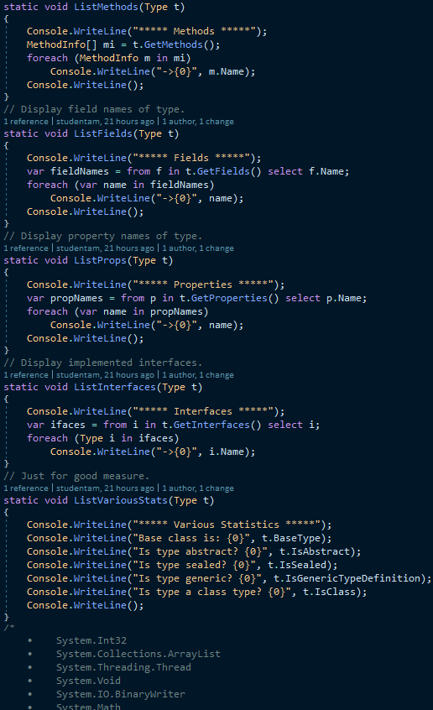

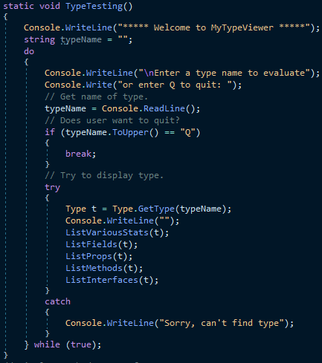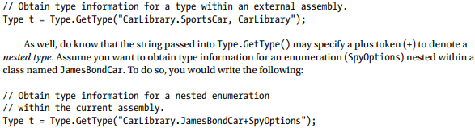

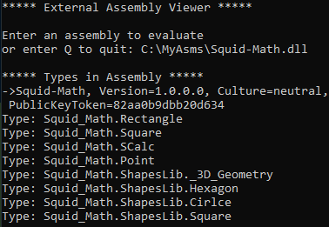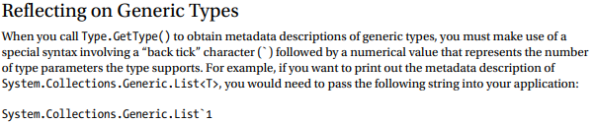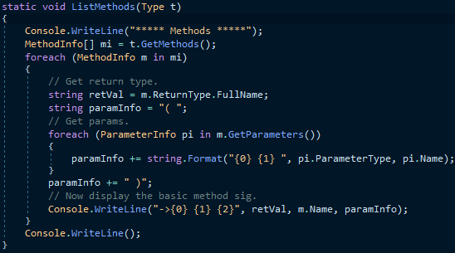

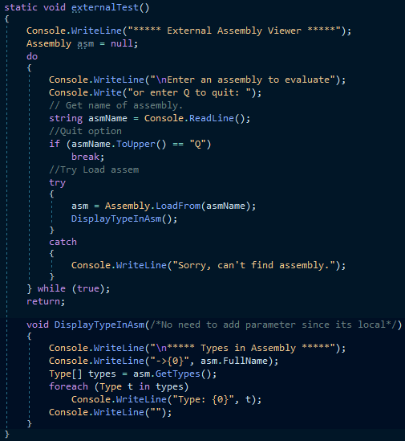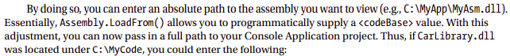**Dynamically Loading Assemblies** In Chapter 14, you learned all about how the CLR consults the assembly manifest when probing for an externally referenced assembly. However, there will be many times when you need to load assemblies on the fly programmatically, even if there is no record of said assembly in the manifest. Formally speaking, the act of loading external assemblies on demand is known as a dynamic load.

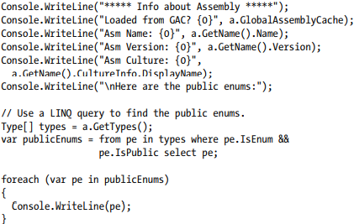**Reflecting on Shared Assemblies** The Assembly.Load() method has been overloaded a number of times. One variation allows you to specify a culture value (for localized assemblies), as well as a version number and public key token value (for shared assemblies). Collectively speaking, the set of items identifying an assembly is termed the display name.

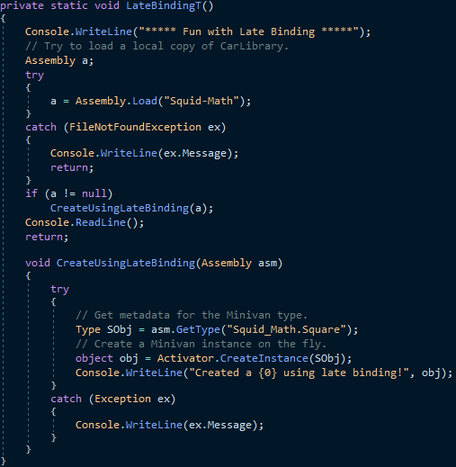**Understanding Late Binding** Simply put, late binding is a technique in which you are able to create an instance of a given type and invoke its members at runtime without having hard-coded compile-time knowledge of its existence. When you are building an application that binds late to a type in an external assembly, you have no reason to set a reference to the assembly; therefore, the caller’s manifest has no direct listing of the assembly. At first glance, it is not easy to see the value of late binding. It is true that if you can “bind early” to an object (e.g., add an assembly reference and allocate the type using the C# new keyword), you should opt to do so. For one reason, early binding allows you to determine errors at compile time, rather than at runtime. Nevertheless, late binding does have a critical role in any extendable application you may be building. You will have a chance to build such an “extendable” program at the end of this chapter, in the section “Building an Extendable Application.” Until then, let’s examine the role of the Activator class.

**The System.Activator Class** The System.Activator class (defined in mscorlib.dll) is the key to the .NET late-binding process. For the current example, you are interested only in the Activator.CreateInstance() method, which is used to create an instance of a type à la late binding. This method has been overloaded numerous times to provide a good deal of flexibility. The simplest variation of the CreateInstance() member takes a valid Type object that describes the entity you want to allocate into memory on the fly

**Invoking Methods with No Parameters** Assume you want to invoke the TurboBoost() method of the MiniVan. As you recall, this method will set the state of the engine to “dead” and display an informational message box. The first step is to obtain a MethodInfo object for the TurboBoost() method using Type.GetMethod(). From the resulting MethodInfo, you are then able to call MiniVan.TurboBoost using Invoke(). MethodInfo.Invoke() requires you to send in all parameters that are to be given to the method represented by MethodInfo.

**Invoking Methods with Parameters** When you want to use late binding to invoke a method requiring parameters, you should package up the arguments as a loosely typed array of objects.

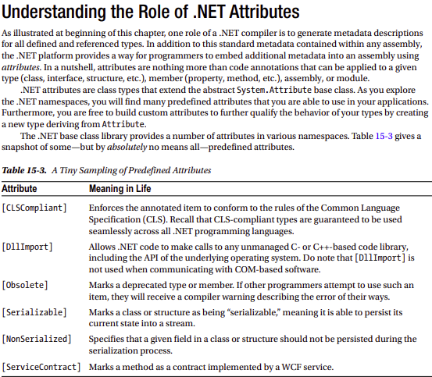 **Attribute Consumers** As you would guess, the .NET 4.6 Framework SDK ships with numerous utilities that are indeed on the lookout for various attributes. The C# compiler (csc.exe) itself has been preprogrammed to discover the presence of various attributes during the compilation cycle. For example, if the C# compiler encounters the [CLSCompliant] attribute, it will automatically check the attributed item to ensure it is exposing only CLScompliant constructs. By way of another example, if the C# compiler discovers an item attributed with the [Obsolete] attribute, it will display a compiler warning in the Visual Studio Error List window.



**Applying Attributes in C#** To illustrate the process of applying attributes in C#, create a new Console Application project named ApplyingAttributes. Assume you want to build a class named Motorcycle that can be persisted in a binary format. To do so, simply apply the [Serializable] attribute to the class definition. If you have a field that should not be persisted, you may apply the [NonSerialized] attribute.

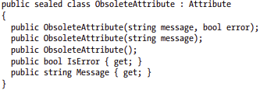C**# Attribute Shorthand Notation** If you were consulting the .NET Framework 4.6 SDK documentation, you might have noticed that the actual class name of the [Obsolete] attribute is ObsoleteAttribute, not Obsolete. As a naming convention, all .NET attributes (including custom attributes you may create yourself) are suffixed with the Attribute token. However, to simplify the process of applying attributes, the C# language does not require you to type in the Attribute suffix.

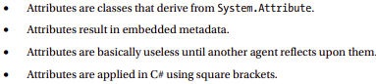**Specifying Constructor Parameters for Attributes** Notice that the [Obsolete] attribute is able to accept what appears to be a constructor parameter. If you view the formal definition of the [Obsolete] attribute by right-clicking the item in the code editor and selecting the Go To Definition menu option, you will find that this class indeed provides a constructor receiving a System.String.

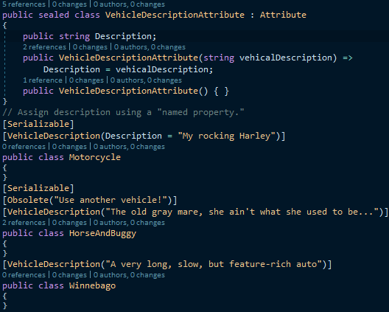**Building Custom Attributes** The first step in building a custom attribute is to create a new class deriving from System.Attribute. Keeping in step with the automobile theme used throughout this book, assume you have created a new C# Class Library project named AttributedCarLibrary.

**Named Property Syntax** Notice that the description of the Motorcycle is assigned a description using a new bit of attribute-centric syntax termed a named property. In the constructor of the first [VehicleDescription] attribute, you set the underlying string data by using the Description property. If this attribute is reflected upon by an external agent, the value is fed into the Description property (named property syntax is legal only if the attribute supplies a writable .NET property).

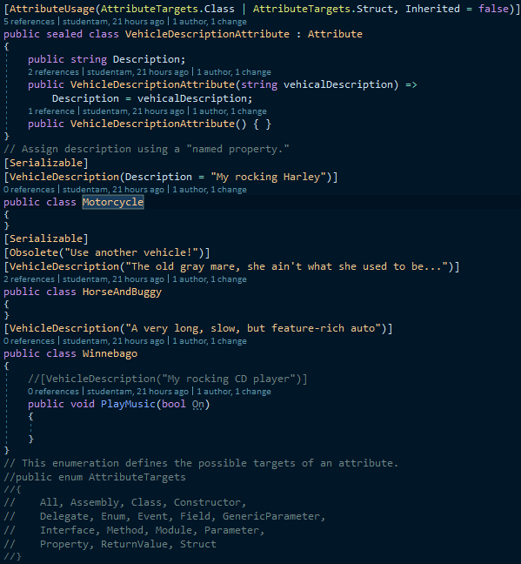**Restricting Attribute Usage** By default, custom attributes can be applied to just about any aspect of your code (methods, classes, properties, and so on). Thus, if it made sense to do so, you could use Vehicle Description to qualify methods, properties, or fields (among other things).

**Assembly-Level Attributes** It is also possible to apply attributes on all types within a given assembly using the [assembly:] tag. For example, assume you want to ensure that every public member of every public type defined within your assembly is CLS compliant.

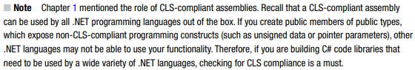**Reflecting on Attributes Using Early Binding** Remember that an attribute is quite useless until another piece of software reflects over its values. Once a given attribute has been discovered, that piece of software can take whatever course of action necessary. Now, like any application, this “other piece of software” could discover the presence of a custom attribute using either early binding or late binding. If you want to make use of early binding, you’ll require the client application to have a compile-time definition of the attribute in question (VehicleDescriptionAttribute, in this case). Given that the AttributedCarLibrary assembly has defined this custom attribute as a public class, early binding is the best option.

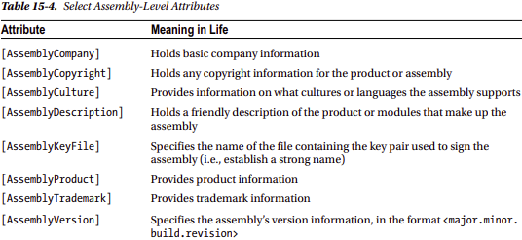**Putting Reflection, Late Binding, and Custom Attributes in Perspective** Even though you have seen numerous examples of these techniques in action, you may still be wondering when to make use of reflection, dynamic loading, late binding, and custom attributes in your programs. To be sure, these topics can seem a bit on the academic side of programming (which may or may not be a bad thing, depending on your point of view).

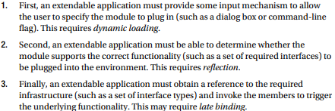**Summary** Reflection is an interesting aspect of a robust OO environment. In the world of .NET, the keys to reflection services revolve around the System.Type class and the System.Reflection namespace. As you have seen, reflection is the process of placing a type under the magnifying glass at runtime to understand the who, what, where, when, why, and how of a given item.